Father and son making up lost ground. Danny and Pepijn Ronaldo create ‘Sono io?’
Posted on 25 September 2020 · ·

I set off from my place in Borgerhout to interview Danny (49) and Pepijn (21) Ronaldo, father and second son, about their new creation Sono io?. Happy to have a reason to travel more than 20 kilometers from my home for the first time in seven weeks, I arrive at the field in which the caravans of Circus Ronaldo stand. The sun is generous, so we can sit outside and avoid breaking our bubbles. Disinfected tea slides across the table.
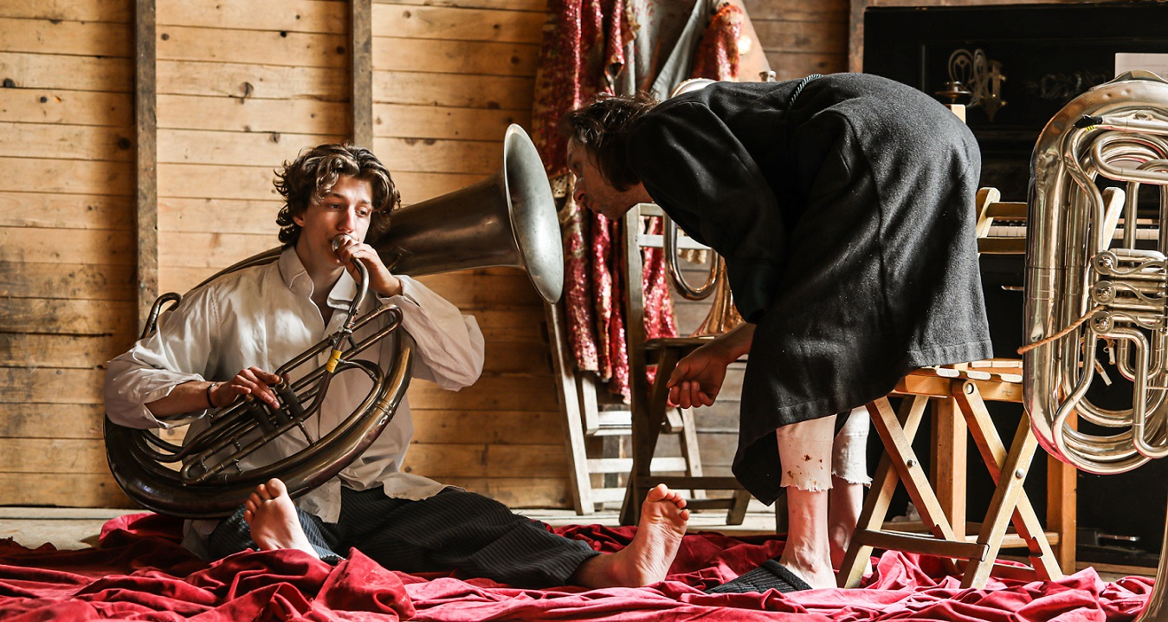
Pepijn (left) and Danny Ronaldo (c) Joke Van den heuvel
That he can’t remember the last time he spent so much time in one place, says the father, how long have we been here now? Time is a blur. “Normally the sky here is full of vapour trails from all the jets.” Background noises have also disappeared. But not only that. How does a clown feel without an audience? Danny and Pepijn were meant to go into premiere in August, with months of playing and travel to look forward to. For the time being they are creating nothing for nobody. A conversation about fish, expectations and achievements. The father usually comes up with answers more quickly. The son is a man of few words, and speaks only when his father doesn’t, but shares the same language, rich with images.

How are both of you doing?
Danny Ronaldo: “It’s all pretty weird, the seeming meaninglessness of it all. If you are working toward a premiere that’s suddenly no longer needed, it’s a strange feeling. First we thought we would just continue, without the composer, musicians or coaches we had lined up. But now we are at the point of pushing the whole thing off for a year and making something in the meantime that can work within the corona-possibilities, with more people on stage, so that everyone in the company can be involved. They are also dying to play. It does give us a rest – though I must admit I am not good at taking it – and that feels good. For the last ten years I have lived at an incredible pace. You get attached to that. The excitement flatters your ego. It’s hard for me to accept having so much time to make this performance.”
How does he feel, a clown without an audience?
Danny: “Sometimes it is not enough to witness something really beautiful and keep it all to yourself. You want to share the feeling. That is what I love about a performance: sitting together in a circle and realising that you are all laughing at the same moment about the same thing in spite of yourselves. That is such an important orientation and comfort, the realisation that we are all the same. These past years there has been a lot of talk about diversity and the need to accept each others differences. That is true, and it is necessary, but it’s also important to feel how very much we are all the same.”
Pepijn Ronaldo: “I think we are at a tipping point, but that it won’t keep us from continuing to play. We have so much desire to play and I thing that the audience has just as much desire to watch us. Perhaps we will have to color things in a bit differently after the pandemic, but we will still be using the same pencils. It is a good time for reflection. I experience a lot of solidarity, it spurs us on to do things together, listen to each other, appreciate each other. Playing itself is for the moment a pretty abstract thing. The pleasure of pretending to be somebody else, I’m dying to do that again. But patience is a virtue. Longing for something can also be a good thing, once we can finally play again it will feel so good.”
Danny: “If I don’t play for three months, and then I have to go back on stage, I always get the feeling that I won’t be able to do it anymore. In the first performances I notice how awkward I have become. Breathing, making contact with the audience, I really have to rediscover all of that. Pepijn has just graduated. Now he is taking a run-up to something that is going to last a long time.”
Pepijn: “There is a positive side to it all: you realise that even if you have a place in an established company like Ronaldo, nothing can be taken for granted.”
How can we come to terms with all of this when for the time being there are no performances for comfort or to help us take some distance from the crisis?
Danny: “The danger with this corona epidemic is that we risk drawing the wrong conclusions. It is clear that we are at a crossroads. Something has ended. There was something missing and we have to think very hard about what that was. But we won’t find solutions in a contact-less society. I am afraid for the inevitable friction between the audience which accepts the risk of infection and others who find that attitude irresponsible. If the public no longer can come to an agreement, then it is going to get messy. And as a player you have no control over that. We will really need healing beauty to help people through this. Everyone will have to pass over that bridge from what was to what is. Circus can play an important role in that process, because it can reach and offer culture to those who are not touched by other forms of art. We can be a mirror for one another. That is what separates us from the other animals. It goes beyond a cat who survives by seeing another cat licking on something and thinks, ‘hey, I think I’ll also try that’. It is a comfort to feel the emotion of someone else, and recognise your own emotions in that. It gives us comfort and direction in our lives.”
If life is reflected in what we see in the circus piste, how do things look there at the moment?
Danny: “We change direction regularly, a bit as a result of this corona atmosphere. Our characters are lonelier than we intended. More helpless. But I find that rather beautiful. We forgot how vulnerable we are. I don’t think that hurts the piece. There is not a lot of outside influence at the moment, but we’ve started to make music with little objects ourselves. Maybe it will all become smaller scale and simpler than we had originally imagined.”
Pepijn: “When I go to the store these days, it almost feels like I am watching a performance. You start to really appreciate something as simple as seeing someone and hearing them speak. Now simply walking around the block gives you a feeling of being away from home, of vacation. You used to have to go through a lot more effort to experience that. You learn the value of the smaller things, and I think that that is also what culture and circus do: waken an appreciation for the things that you took for granted.”
Danny: “You look with new eyes at all the things you knew. It makes you laugh. Or it touches you. Our society functioned on illusions. We built ourselves a funfair where everything was possible, where everybody just consumed, but we didn’t realise that there was a parking lot, where the funfair came to a halt. No awareness of that. And now the life we took for granted has abruptly ground to a halt. We’ve reached the limit. And that also feels good. I like it when things come to an end. For me a performance has to have a beautiful ending.”

A fishbowl on a table above the sea
In Fidelis Fortibus you showed us a character struggling with the past – a past that was so dear to him – in order to come to know himself. Now you are on stage with your son, who has just graduated. Is it approaching, the time to pass the torch?
Danny: “I don’t have anything left to prove, whereas Pepijn is fresh out of school. If the press and the audience come to see our premiere, they will come to see if I can still do it and if Pepijn can do it yet. We are trying to prepare ourselves to deal with that attitude.”
Are you giving Pepijn the room he needs to spread his artistic wings?
Danny: “If you put a goldfish in a little fishbowl, he stays small. Put him in a larger pond, and he will become a giant fish. Fish have a sense of how large they may grow. You see in the performance a father who really wants to help and support his son, but who at the same time takes a lot of room himself, which gives the audience the feeling that the boy has to leave his father, if he wants to grow.”
How do you experience that, Pepijn?
Pepijn: “I am the fish in that beautiful fishbowl. I feel myself holding back, and that feeling is reenforced by this corona crisis. Soon I can go back to the piste, but for the moment I am a tightly coiled spring, who is not sure exactly in which direction he will explode. I am a young guy, papa is a bit less young. For the rest I think we share the same goals and vision, he has done a lot and proved a lot, my eye is still fresh, I am full of desire.”
How do you create together? Do you talk a lot? Or do you mostly ‘do’?
Danny: “We talk a lot. A lot is decided in theory. Only just before the performance do we show each other more or less how we will do things once the audience is there. Before that it’s mostly a lot of dreaming, trying to put into words what you imagine, what you would like to see. Or adding to the scenography by moving things around. Feeling how the other plays, that’s very new for us, that only happens in front of the audience.”
How do you escape the parent-child relationship during the rehearsal process?
Pepijn: “It’s a strange dividing line between being a son and being a colleague. You stand there as a rookie next to a big man, who is at the same time your father and your hero. It is all very warm and at the same time I feel like I know nothing, and am very unsure of myself. But I do feel an artistic bond there, and that magic happens when we are together.”
Danny: “That just happens.”
Have you gotten to know another side of your son? And you your father?
Danny: “I am a bit ashamed of how much of my time I have been able to devote to my children. Of all my children Pepijn is the one I saw the least of when he was growing up. Now we have a chance to make up for some of that lost time.”
Pepijn: “I also see it as a chance to catch up. I am getting to know him in a different way, yes, a much more personal one. He is no longer the example out there in the distance.”
Danny: “Yet to some degree I still wear my father mask. Just like every father I try to show my best side; just as every son Pepijn wants to make his father proud. Though it’s not our goal to expose it completely, it is our relationship which is the starting point of this play.”
Danny (left) and Pepijn Ronaldo (c) Joke Van den heuvel

Shadow
Pepijn, do you feel like you have to emancipate yourself twice, once from your training and once from the example of your father?
Pepijn: “I think that at school [Pepijn went to the Brussels theatre school Lassaad, red.] I received a way of looking at things, that is still very vital to me and that I want to share with my father. One of the teachers said to me: ‘if you want to be creative, you have to act like everyone else’. That really stuck with me. My school had a pretty traditional approach to acting, to what theatre is. I think that I am now learning to let go of that. There are so many rules, but at the same time none of them are written down. My training has made me stronger, but also weaker sometimes. I am looking for a balance in that now, during our creation process.”
Danny, what has he taught you?
Danny: “More than anything his hunger to always discover something new. If I can do a trick, I am pretty quickly satisfied that I can do it, and hold onto that. But Pepijn keeps searching. He is less bothered if something fails. He can let go more easily, while I try to repeat one hundred times what I did yesterday, until I can do it perfectly. For Pepijn that was yesterday, and he wonders what might happen today. When I saw Pepijn’s graduation project, I was so touched by his lightness. Only then did I feel how much weight I carry around with me. My body is falling apart, but that doesn’t really bother me. Sometimes it hurts a bit, but it’s still not holding me back. Mentally however I catch myself doing the same things my father would do. He lived a lot in the past. Photos, souvenirs, old things. He didn’t want to make anything new, he wanted to keep things as they were. I always tried to pull him out of that, but now I see the same behaviour in myself. That I sit there scrolling through old photos, or rereading old newspaper articles. It makes me sad to discover I’ve got that same melancholy, but there’s nothing I can do to make it go away.”
Is that why you brought Pepijn along, as a way to confront yourself?
Danny: “Maybe yes, subconsciously, my character wants to do something, make something new, take space and status. For me that is the blessing of theatre, that you can take the things you wrestle with, your own fears and dreams, and share them with and audience. You don’t really have too many chances to do that in traditional circus, even if on the whole I prefer the old circus to the new. In traditional circus you have to keep up the illusion that things are still as good as they used to be. Artists hide their true feelings under their makeup. While that is the most beautiful thing you can show the audience, how old you are and the fear that goes along with that. But then the paradox is that the audience doesn’t always recognise the theatricality of that act. Then they come to me after the show to tell me that I used to be such a carefree actor, but not any longer, that I should make simpler easier things. As if everything in the circus is real. I’m already preparing myself to hear all of that once again with this show, ‘if I may be honest, Pepijn would be better off sharing the stage with other young people, because that father of his is holding him back’.”
Pepijn: (laughing) “In this play we put two phases of life next to each other on stage and I think that it’s really beautiful to show how they can clash. I am real go-getter and I know somewhere that my father also was 20 years ago, even if now he looks at things differently. Realising that that is how I might look at things in 30 years’ time, means that there is recognition on both sides. I can imagine that for my father there is a lot of melancholy in seeing me dream and how full of energy I am. I see someone who has accomplished so much, and who now wants to show another side of himself, at home in the piste. I think it’s wonderful that I can be part of that. We each welcome the other to be completely themselves in the performance.”
And that leaves you enough space for your own dreams?
Pepijn: (laughs)
Danny: “I think that that is precisely what the show is about. Pepijn will certainly have beautiful solo moments in the show, where I am literally out of the picture, during the creation and during the performances as well. We did that at some point during a tryout, I just left the stage and Pepijn stayed there alone, I am not even sure what he was doing, but I heard him, and listened to how the audience was reacting and if they had to laugh. The first thirty shows of Ronaldo are never good, it always takes us a long time to get things right. That’s again what I like about the old circus, that there was time for everything. Clown numbers were never rehearsed, they just grew by doing them. Clowns would start out in the smaller circuses, develop their act, and then go on to the better circuses from there.”
Pepijn, you are starting out in a very big spotlight, with all the expectations that brings…
Pepijn: (laughs)
Danny: “We know there are expectations, but that is exactly what the show is about. There will be moments where either he or I will fail. We are going to bite the dust. And the expectations are so high that it won’t just be dust, we will wipe out in splinters of glass. But it is the first time in my life that I am not so afraid of that, because that’s the whole theme of the piece.”
Conflicts sometimes between the two of you?
Danny: “Not enough actually, sometimes I think we could use more of that.”
Pepijn: “Neither of us like conflict, we are too quick to try to understand each other. It’s all rather congenial.”
Danny: “If you have conflicts, you can use them in the performance, to create storylines or situations. Everyone is waiting for the cliché of the father who wants to teach his son to drive, and says after the first lesson: ‘never again’. But the show won’t have those kinds of conflicts. It is about two people who look at each other and support each other, and in doing so also pull each other down. The father casts a shadow over his son, involuntarily, because he is so proud of him and wants to show him off. At the same time he still needs to be the center of attention. That was the same with my father. When I was twenty and we were asked for an interview, my father would jump in after three sentences and would start finishing my sentences. He couldn’t help himself. I catch myself doing the same thing.”
Pepijn: (laughs)
Danny: “And yet you don’t see a rebellious son here, but one who will support his father. One who, if he sees that the trick doesn’t work, pulls some strings without his father seeing, so that the trick finally does work. So that the father can maintain the illusion of his capability.”
Father and son dish up some soup. The day stumbles on. In a while they may go rearrange the stage. That is the beginning of the performance which is not yet allowed to be. But we already know how it will end: it will be beautiful or it won’t be.

World premiere was foreseen for summer 2020 at Theater of de Markt in Hasselt, but the pandemic got in the way… for the latest updates, check: www.circusronaldo.be and www.fransbrood.com

This article was published in Dutch in Circusmagazine #63 – June 2020 // Author: Ine Van Baelen // Pictures: Joke Van den heuvel // Translation: Craig Weston // Copyright: Circuscentrum – please contact maarten[at]circuscentrum.be for more information

