ANECKXANDER: The man behind the trick
Posted on 31 July 2015 · ·
[This article was published in CircusMagazine #43 – June 2015]
[Author: Evelyne Coussens – Photography: Tom Van Mele – Translation: Craig Weston]
[Copyright: Circuscentrum – Please contact maarten[at]circuscentrum for more information]
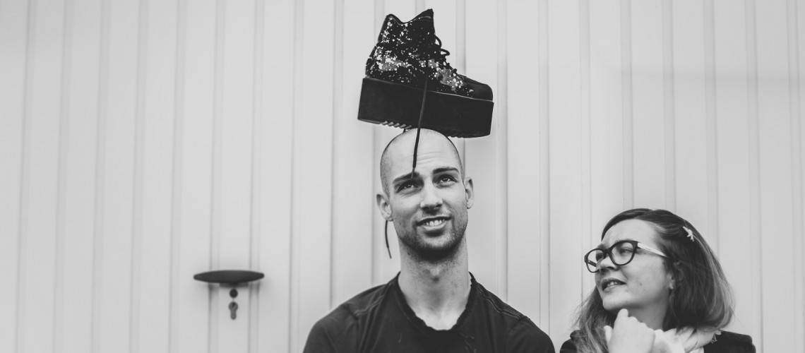
Alexander Vantournhout and Bauke Lievens (c) Tom Van Mele
Alexander Vantournhout speaks just as he is: with the lucid practicality of a circus artist and the philosophical reflection of a dancer. Bauke Lievens adds to, questions, and challenges. Together they have created the performance ‘ANECKXANDER’ – a sometimes tragic, sometimes humorous self-portrait of the circus artist as lonely body.
It’s the large eyes with the charming long lashes, it’s that young, open face on top of that uncommonly muscular body, a body that in the course of an hour moves to complete exhaustion. The Brussels try-out of ‘ANECKXANDER’ clarifies and illustrates the conversation that I had a few days earlier with the makers, in Alexander Vantournout’s hometown Roeselare. How should you read Alexander’s body, what does it tell you about his identity? That is the central question of the new solo ‘ANECKXANDER’, that is scheduled to premiere in PERPLX at the end of June.
Alexander, you are trained both as a dancer and as a circus artist. In which of those roles do you feel the most at home?
Alexander Vantournhout: “It varies from project to project. My identity shifts in correlation with the way I use my body on stage. With ‘ANECKXANDER’ perhaps I feel more the acrobat. With my last solo, ‘Caprices’, I had to draw more on my power and speed. With each production I try to develop an ‘other body’.”
Up until now, you have tended to create solos. Is it difficult for you to work with other people?
Vantournhout: (laughs) “That’s a question I ask myself sometimes, but it has more to do with the fact that circus is essentially a non-collaborative art form. In contrast, dance is based on dialogue: if you dance together you learn from and with each other, by watching one another. A dancer is obliged to work in different companies and his individuality must be more ‘liquid’. Circus is aimed more at the specificity of the artist: you use an object to differentiate yourself from another.”
Bauke Lievens: “There is also a sort of sociological tradition: circus is often about a ‘freak’, a loner who lives in the margins of society, because he does something that is strange, unusual or dangerous. The community comes to watch that individual.”
Where are the meeting points between circus and dance, and how do they differ from each other?
Vantournhout: “If you look at it from the level of the medium itself, then the only real difference for me lies in the presence of an object. The big problem with circus is that little of its artistic potential has been explored, there is still so much left to be discovered.”
Lievens: “In dance the relationship between the body and the movement, or between the movement and the music, is constantly being pushed further. Whereas circus relies much more on the idea of standard ‘tricks’. As a result, you quickly find yourself in a petrified repertoire of movement. As a performer, it’s easy to fall back on the traditional tricks that the audience already knows so well.”
Vantournhout: “If you perform a trick you can’t ‘play around’ with it that much, nor can you really add much in terms of new or different meaning. That has to do with the inherent danger: you have to give all your attention to successfully doing the trick, you have to be completely ‘in it’, and there is little room for interpretation. For that reason a trick communicates little beyond its own virtuosity.”
Lievens: “If a dancer raises his arm, that can mean something different, a thousand times over, but a circus trick is often so stuck in its codes that it is difficult to see anything new in it. The traditional circus spectator is watching with an eye for virtuosity. And ninety procent of what is created confirms and encourages the public in that pattern of observation.”
Does ‘ANECKXANDER’ attempt to develop a circus language that is less set in its ways?
Lievens: “I believe so. Usually in circus, you see the trick, while we are trying to show you the man behind the trick.”
Vantournhout: “The challenge will lie in managing to bring along the fans of cirque-nouveau as well, because we don’t want to lose them. At the same time we want to attract a new audience. The goal is to get those two audiences to sit down together.”
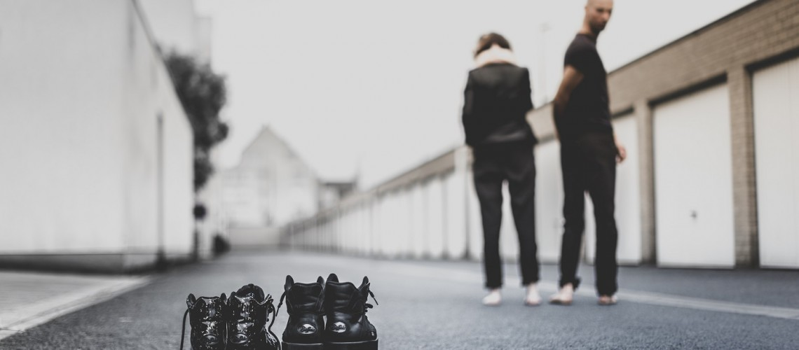
Alexander Vantournhout and Bauke Lievens (c) Tom Van Mele
THE IMPERFECT BODY
In ‘ANECKXANDER’ you magnify the small imperfections in your body, Alexander. Were those imperfections ever problematic for you?
Vantournhout: “I never had a complex about my body, if that’s what you mean. (laughs) I always accepted my body for what it was. But in the last years of my dance education, (Vantournhout was a student at P.A.R.T.S.) we analysed in depth the proportions of our bodies, and how we could explore that aspect. Only then did I realize there were some ‘strange’ things about my body. My torso is slightly too large in relation to my legs, my neck is too long, my forearms are too wide for my biceps. In ‘ANECKXANDER’ I try to go beyond those quirks, to use them to my advantage, and to show that I am more than just my body.”
Lievens: “That’s the same case for me, to some degree. I have a wine-stain on my face, but it is only now, through talking about it here, that I realise how auto-biographical this theme is for me: the manner in which people are reduced to a sum of physical characteristics, and a resistance to that phenomenon. Strangely enough, I have the impression that my body is more accessible than that of another, precisely because my wine-stain immediately gives so much away. I wear a visible sign that has formed my character, while others carry such things on the inside, hidden from others. So I have the feeling that I am very readable, that people quickly suss out who I am.”
Vantournhout: “It is very honest. The vulnerability of imperfection does not create a barrier, but rather calls up a sort of love and warmth from the other.”
In ‘ANECKXANDER’ the artist on stage evolves from an everyday person – a man in a suit – to a naked, dancing body, challenged in several different ways. What does this evolution mean?
Lievens: “The performance begins on a sort of ‘neutral ground’: with a normal undistinguishable man,. As time goes by we begin to make him identifiable, by showing his nakedness, by showing that his body is imperfect, and finally by insisting on those imperfections.”
How does that happen?
Lievens: “Objects get added to that body. No classic circus objects, but rather extensions, protheses. They must compensate for the vulnerability of the body, but because the man is naked, they only succeed in emphasising his vulnerability. He dances the same choreography three times, and each time an object is added. Initially, hat object makes the choreography more difficult, introduced as a handicap and limitiation. It sets him back. But, as time goes by, it slowly evolves into a tool of comfort and an accessory. After a while the objects help accomplish tasks that the body could not accomplish without them. They transform from obstacle to instrument.
How did you choose the objects?
Vantournhout: “There are not so very many possibilities. If you want to lengthen your legs, you soon resort to heels or buskins. If you want to lengthen your arms, you come up with boxing gloves. We specifically looked for objects that not only lengthened the limbs, but also influenced the quality of the movement.”
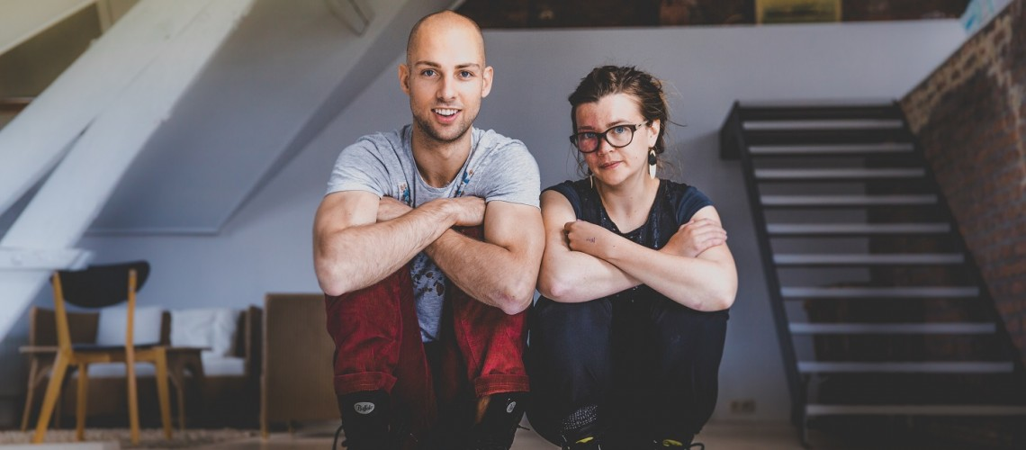
Alexander Vantournhout and Bauke Lievens (c) Tom Van Mele
AUTOBIOGRAPHY
Your choice to play with the ‘imperfect’ body is noteworthy in a circus and dance context where the perfection of the body is of paramount importance.
Vantournhout: “I am not sure that that theory holds for the circus world. Tn the dance world it is indeed true that age, for example, matters: you may not begin your career too late, and an ‘old’ dancer has immense difficulties in finding work. But I have the feeling that things are slightly different in the world of circus: a circus-artist that is physically too ‘old’ simply eases into the function of mentor.
Lievens: “Do you really believe that, Alexander? In the circus world the aspiration for perfection and for the perfect body is equally present, to my mind. I even get the feeling that there is less room for unusual or subversive body-types than in dance. In circus it is always about the perfect figure and as a result never about the exception to the norm.”
But does ‘ANECKXANDER’ offer criticism or commentary on this issue?
Vantournhout: “At any rate, it was not our goal to inject some explicit, moralistic message into the piece, but by the fact that we we are searching for another, imperfect body-language you could say that there is something we refuse to accept. But that resistance is to be found in our physical vocabulary, not in a literal message. “
Lievens: “I find that circus is infused with a large autobiographical character, though circus-artists are seemingly unaware of that fact. Everything in circus is about your own body – if you fall from the trapeze it is you that dies, not someone else. It is constantly your body that is in danger. This creates a closer bond between who you are and what you do than in the theatre, for example. With ‘ANECKXANDER’ we try to create a circus language that originates in the autobiographical quality of Alexander’s body – that is something that almost never occurs in circus, the link between the body and the identity of the artist. For me that is very important: the fact that Alexander’s body is not replaceable, that it is unthinkable that someone other than him could play this piece.”
TRAGIC
You call the piece a ‘tragic’ autobiography. Tragedy is is to be found in the struggle between man and the larger powers which surround him, and in the fact that it is a struggle he is destined to lose. To what degree is this dimension present in ‘ANECKXANDER’?
Lievens: “The dimension of the impossible struggle is already an integral part of circus in general, I believe. Circus is the doomed attempt of the artist to achieve a goal that continues to place itself out of reach. Take for example ‘balance’, one of the greatest goals in circus. A hopeless endeavor, because something like balance doesn’t exist – at best one can only attain a brief reprieve from imbalance. Actually, in the circus, one never wins. You cannot defeat a natural law like gravity. You can only try, at certain moments, not to be defeated by that law. In the spectacular circus the emphasis is placed on those brief moments of ‘victory’. In ‘ANECKXANDER’ we try to do exactly the opposite; we show that we have at least not been completely beaten. We show the struggle between a man who comes up against his limits and the limits of nature. I think that is a completely different starting point.”
Vantournhout: “That sort of circus shows a humanity which is much more tragic than the circus that aims to ‘surpass’. In a lot of traditional circus the artist tries to rise to the status of ‘super-human’, but you can’t sustain that role if you are out to express the contemporary human condition. The virtuosity of the tricks is not suited to telling the story of frail humanity. So in place of the tricks, you have to go in search of a new circus language.
Why is the development of a more artistic circus language such a slow-going process?
Lievens: “I think there are a lot of different reasons for that, but the central problem is that the centers of training and education still define circus as a medium based on technique. At best they combine this approach with an old-fashioned idea of theatre, in which the technique has to be fit into a little story. Right now, people are still accepted to the schools on the basis of their technical proficiency, and less on whether or not they are interesting individuals. Both qualities are necessary, and perhaps the circus schools need to include the possibility for specialisation, as one can do in the theatre. In a theatre education one can choose if one wants to become creator or performer. At ESAC and CNAC everyone graduates as ‘artiste de cirque’, everyone graduates with the title of creator – while the student has only been trained in technical skill. For three or four years you are trained to perform a particular skill to perfection, and afterwards you and your friends form a company where technique and the sttruggle for perfection are central, but there is little or no attention given to artistic research. There is so little awareness of the fact that the act of creation is a process. It is a journey in which you can make mistakes, and in which you can fail.
www.alexandervantournhout.be
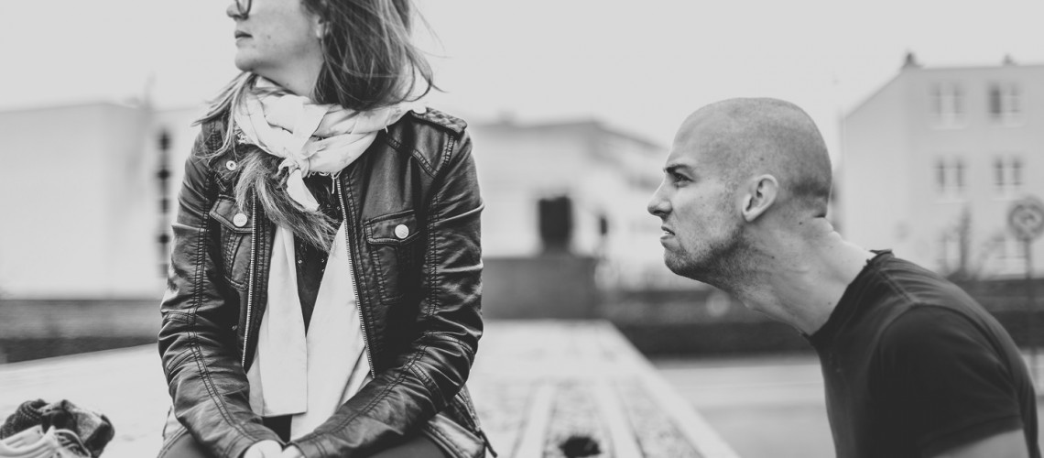
Alexander Vantournhout and Bauke Lievens (c) Tom Van Mele

