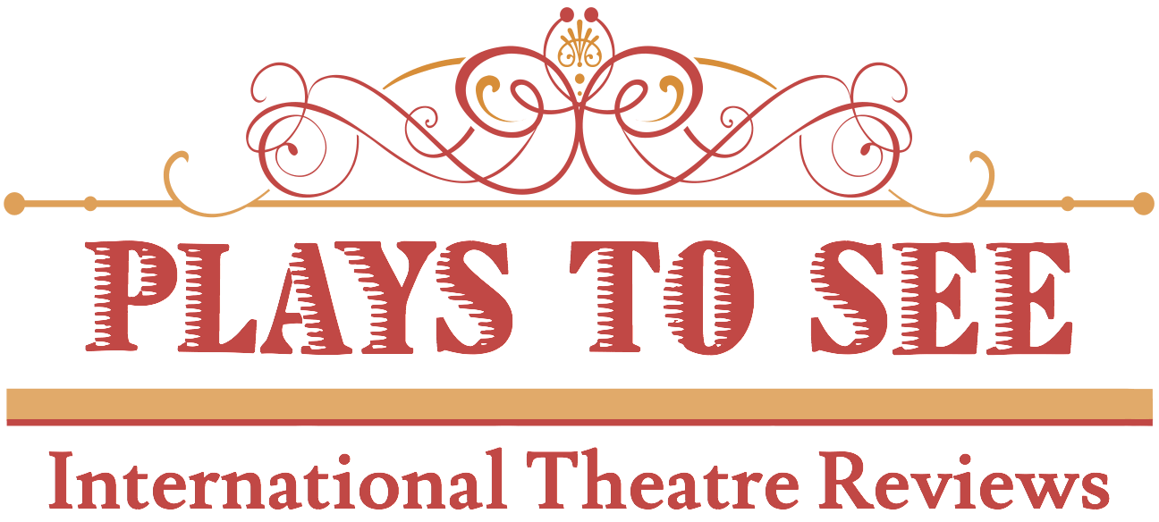

ANECKXANDER
Review by Hannah Connell - 23rd January 2016

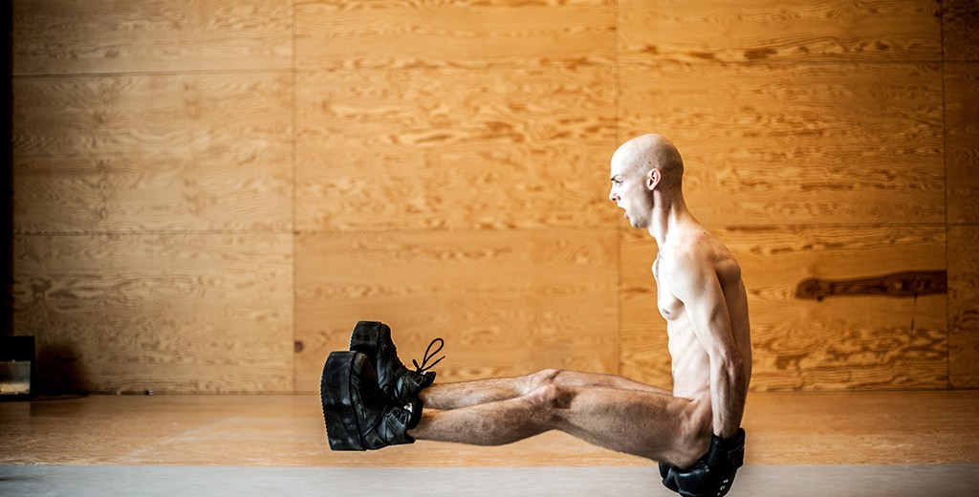
Physical Theatre
Conception: Alexander Vantournhout and Bauke Lievens
Performer: Alexander Vantournhout
Dramaturgy: Bauke Lievens
Music: Arvo Pärt

Reviewer’s Rating: *****
Aneckxander is a compelling exploration of the artist’s relationship with his body. This daring piece of physical theatre is at once hauntingly tragic and touchingly humorous. Alexander’s performance explores the vulnerability of our bodies and the physical and discursive boundaries we create for them. It is a graceful and touching portrayal of human endurance and curiosity.
Aneckxander portrays a metamorphosis of the form most familiar to each of us, our body. The performer alternates between contorting his body into unrecognisable shapes and daring acrobatics which explore the confinement of the self in particular forms and the desire to overcome restriction. Aneckxander exposes the creative potential of the human body if we can only let go of our preconceptions of its physical limitations.
In a suspenseful escalation of sound and dance Alexander challenges the audience to reflect upon an undercurrent of violence in the relationship between the artist and his body. Through the power and grace of this extraordinary choreography Alexander’s movements expose a desire to reclaim the body from a hostile world. Through repetitive movement he depicts the difficulty in overcoming the uncomfortable thresholds of social perception; though his body is tethered in place and weighted down by expectation, he still fights against this inertia.
The stark black and white stage floor is an integral part of the performance, reflecting the physical limitations of our environment. Alexander pulls up the floor, balances on the edge of the abyss and finds himself stuck in unknown territory. The poignant minimalism of the set, with its interplay of light and dark, is echoed in the music by Arvo Pärt. Tender, lingering notes accompany Alexander’s solo performance.
Aneckxander is provocative, ambitious and playful, all at once. It boldly walks a delicate line between comedy and catastrophe capturing, completely, the audience’s attention, both defying their gaze and embracing it.
Source: http://playstosee.com/aneckxander/?platform=hootsuite

