Kalakuta Republik at the Barbican
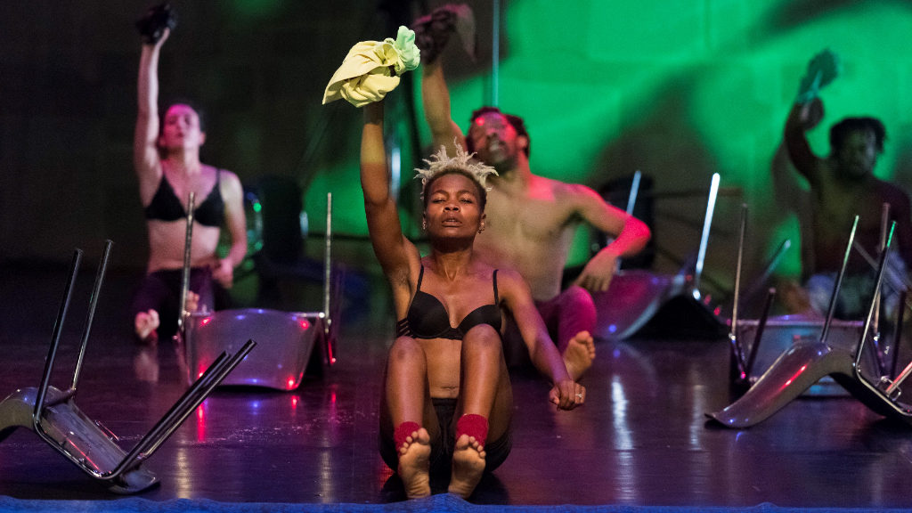
31 May 2019

Marissa Khaos
★★★★★

Serge Aimé Coulibaly and his Faso Danse Théâtre present Kalakuta Republik for the first time to a London audience at the Barbican, which witnessed the revival of the political and artistic dissidence of the Nigerian superstar and legendary figure Fela Kuti. This dance piece, which explores the struggle for freedom against oppression through the endless movements of the body that exists as the site of rebellion, is inspired by music from Kuti whose creative influence continues to inspire the young generation of activists, artists and lovers of jazz and Afrobeats.
Coulibaly’s choreography is ecstatic, engaging and teeming with vibrant energy that explores the capacity of music, the body and space to question constructed realities. The first part, Without a Story We Would Go Mad, presents the dancers in black and white, their individual movements and the dialogue with the group representing the black and white nature of our understanding of a divided world – one that is connected by a complicated web of nuances that the dancers’ bodies express through the disjointed and erratic choreography. Coulibaly explains that this piece represents “the world of today, the fear, violence and indifference that always seems to catch up to us”.
This world is challenged in the second part, You Always Need a Poet, which explores the crude sexuality, absurdity, chaos and colour of the dramatic break from indifference. This act is animated with bright colours, flying chairs, laughter, noise and a cloud of dust to boldly claim that “all that glitters is not gold”. The red, yellow and blue lights reflecting as if from the cityscape, while the performers move around and away from each other, is an imagining of the spaces that Fela Kuti shared with his audience – namely, the Shrine and the nightclub – which were vital to the political awakening and resistance inspired by his music. True to his vision, this dance performance is a tribute to the iconic artist and a realisation that the struggle for which Fela Kuti gave his life continues to the present.
Marissa Khaos
Photo: Doune Photo
Kalakuta Republik is at the Barbican from 30th May until 1st June 2019. For further information or to book visit the theatre’s website here.
Source: https://www.theupcoming.co.uk/2019/05/31/kalakuta-republik-at-the-barbican-theatre-review/?fbclid=IwAR3ZBaSsT9ULoBFH5CfJL5VHKBhhkSwnjCeh-BDzRNq8DB7ug47yCNY1GPA#

