Kalakuta Republik
Barbican Theatre
Words by: Natalie Murray
Published: Monday, June 3, 2019 8:45 AM

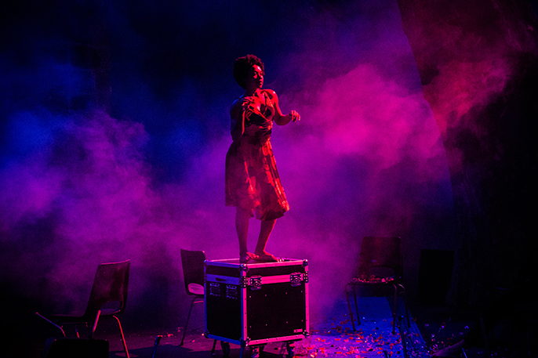

Kalakuta Republik, Barbican Theatre
Faso Danse Théâtre & Halles de Schaerbeek/Serge Aimé Coulibaly, Kalakuta Republik; Ida Faho. Image credit: Sophie Garcia
By the stunning conclusion of the performance, we are left emotional, breathless and awakened.
It starts with a pulse and one individual. As each dancer joins in the motion, the group comes together, you notice it’s a mastery of ensemble movement. The rapid disjointed jumps, flicks and maneouvres work together as one, but still manage to convey the individuality and freedom breaking out in Kuti’s early music which provides the Afrobeats soundtrack.

Serge Aimé Coulibaly’ Faso Dance Theatre group presents a dizzying dance production inspired by the life of Fela Kuti, the Nigerian singer and political activist. The narrative sometimes gets lost in the performances but while the audience isn’t always fully following the sequence of events, there’s a strong feeling created by the mood of each chapter of his life as displayed on stage.
Kalakuta Republik is a love letter to Fela Kuti and his music, an exploration of the group and individual dynamic and a celebration of dance’s physicality and movement.
From the minute the show starts, the audience is gripped by the pulsating energy of the production.
This energy, which runs throughout the show, also feels like a comment on the resilience of the African continent
Coulibaly said that he wanted to ‘experiment with a form of direct and violent dance which never stops’, to illustrate Fela Kuti’s defining characteristic as ‘a man who never gave up’. What Coulibaly creates is a raw visceral production, where energy is transformed from one thing to another as the scenes shift through different periods of Kuti’s life, from the freedom of the early years, the politicization of his message and the death of his mother. This energy, which runs throughout the show, also feels like a comment on the resilience of the African continent - perhaps a note of defiance to European colonisers from the Burkino Faso-born creator and choreographer Coulibaly.
The staging helps to provide the backdrop to the scenes we see play out on stage. We see audio-visual of cityscapes, footage of conflict and quotes.
The second act opens with a quotation, “We all need a poet”, and the mood changes as we move to events from Kuti’s later years. There’s a recreation of the Shrine nightclub. The dancers are bathed in colour in contrast to the black and white of the first act. There is so much energy on stage, it is difficult for the audience to be able to drink it all in at once. Heads loll left and right as they make sure they don’t miss any of the action. It might have been an assault on the senses if it wasn’t all so pleasurable. Kuti’s music guides us through all of it.
Beg, borrow or steal a ticket
Kalakuta Republik refers to Kuti’s legendary communal compound in Lagos which housed his family, band and recording studio. So much of that energy, hope, freedom and spirit is recreated in this production that by the stunning conclusion of the performance, we are left emotional, breathless and awakened. Beg, borrow or steal a ticket.

Source: http://www.afridiziak.com/theatrenews/reviews/june2019/kalakuta-republik.html

